

Subject : BITI1113 Artificial Intelligence
Project Title : Eye Disease Detection System
Lecturer Name: Ts. Dr. Wan Mohd Ya'akob Wan Bejuri
Group No: 25

FULL NAME | MATRIC ID | S/G | PROGRAM
KESSIGAN A/L THIRUNAVUKKARASU | B032310876 | S1G1 | BITS
WONG CHOON KIAT | B032310534 | S1G1 | BITS
JONATHAN MICHAEL LEONG EUGENE | B032310513 | S1G1 | BITS
MUHAMMAD ROHAIZAD BIN ROSLI | B032310485 | S1G1 | BITS

Table of Contents
Table of Contents 2
PART A: PROBLEM STATEMENT 3
Background 3
Problem Definition 3
Objectives 3
Target Users 4
PART B: SYSTEM DESIGN 4
Facts 4
Rules 4
Inference Engine 5
System Architecture 6
PART C: IMPLEMENTATION 7
Tools and Technologies 7
Development Steps 7
Benefits 10
PART D: User Manual 10
PART E: Testing Results 13
References 15

PART A: PROBLEM STATEMENT

Background
Eye diseases such as cataracts, glaucoma, diabetic retinopathy, and macular degeneration are leading causes of blindness worldwide. Early diagnosis and treatment are critical to preventing irreversible vision loss. However, many people do not have access to ophthalmologists or routine eye exams due to geographical, financial, or healthcare system limitations.
Artificial intelligence (AI) offers a promising solution by enabling automated eye disease detection using retinal images. With the integration of machine learning and image processing, an AI-powered system can screen for common eye conditions and assist healthcare providers in making timely decisions.

Problem Definition
The traditional approach to diagnosing eye diseases involves manual inspection by trained professionals, which can be time-consuming and subject to human error. There is a critical need for an automated system that can accurately detect and classify various eye diseases from retinal images to improve diagnostic speed, accuracy, and accessibility.
Not only that, many Ophthalmologists in rural areas also lack access to technology. As a result, many disease cases are delayed or even misinterpreted.

Objectives
- Develop a machine learning model capable of detecting multiple eye diseases using retinal images.
- Automate the diagnosis process to reduce the workload of medical professionals.
- Improve early detection and patient outcomes through AI-assisted screening.
- Enable remote diagnosis to support telemedicine and rural healthcare services.

Target Users
- Ophthalmologists & Optometrists: For validation and workflow integration.
- General Practitioners: Preliminary screening in primary care.
- Public Health Programs: Mass screenings in underserved regions.

PART B: SYSTEM DESIGN

Facts
- Dataset with examples labelled as Cataract, Diabetic Retinopathy, and Glaucoma.
- The image contains the following:
Attributes such as lens clarity, retinal condition, and optic nerve shape.
Dataset with examples labeled as:
- Cloudy lens, blurred vision, and light obstruction.
- Retinal microaneurysms, hemorrhages, and abnormal blood vessels.
- Optic nerve damage, increased eye pressure, and visual field loss.

Rules
- IF the lens appears cloudy AND vision is blurred AND there is light obstruction,
THEN the disease is Cataract.
- IF the retina shows microaneurysms AND hemorrhages are present AND abnormal blood vessels are visible,
THEN the disease is Diabetic Retinopathy
- IF the optic nerve is damaged AND eye pressure is high AND there is visual field loss,
THEN the disease is Glaucoma.

Inference Engine
A forward chaining mechanism was implemented to classify eye diseases based on the detected image features. The inference engine matches the extracted attributes against the knowledge base rules to generate diagnostic recommendations.
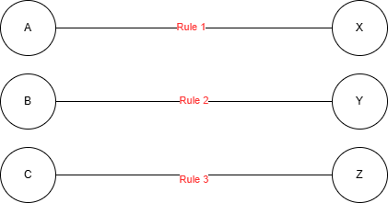
Rule Legend
- A: Cloudy lens, blurred vision, light obstruction → X: Cataract
- B: Microaneurysms, hemorrhages, abnormal blood vessels → Y: Diabetic Retinopathy
- C: Optic nerve damage, high eye pressure, visual field loss → Z: Glaucoma

System Architecture
The system architecture comprises the following components:
- User Interface:
Allows users to upload retinal images for analysis and view the diagnostic results.
- Image Preprocessing Module:
Resizes, normalizes, and converts the uploaded images to ensure compatibility with the trained model.
- Knowledge Base:
Stores labeled examples of eye diseases (Cataract, Diabetic Retinopathy, Glaucoma) and the related diagnostic information such as symptoms and treatments.
- Inference Engine:
Processes the input image using a trained Google Teachable Machine model to classify the eye disease and provide educational and medical recommendations.
- Output Module:
Displays the classification result along with disease descriptions, typical symptoms, recommended treatments, and suggested medicines.

PART C: IMPLEMENTATION

Tools and Technologies
Language: Python
Compiler: Microsoft Visual Studio
Libraries: Anaconda for the user interface
Visual Studio Code for development, and Teachable Machine for data handling and rule-based implementation

Development Steps
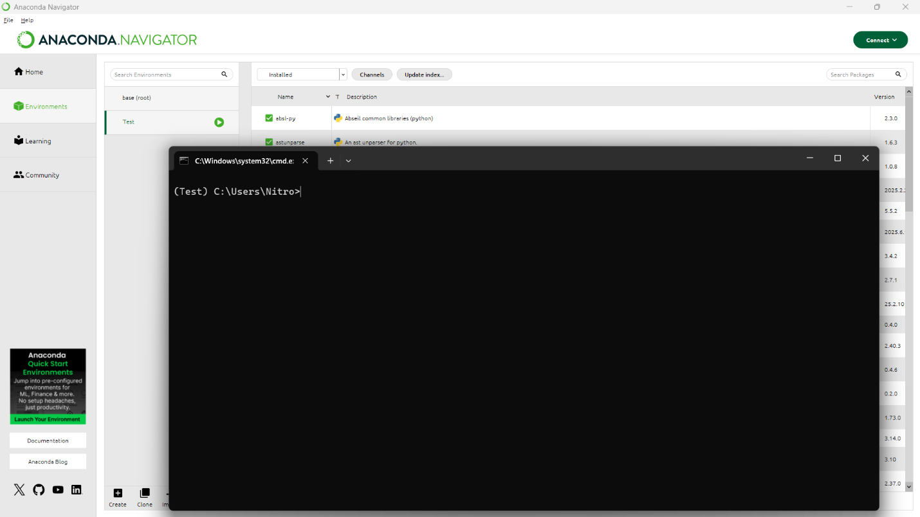Anaconda Navigator used for management of python

Visual Studio as IDE and code compiler

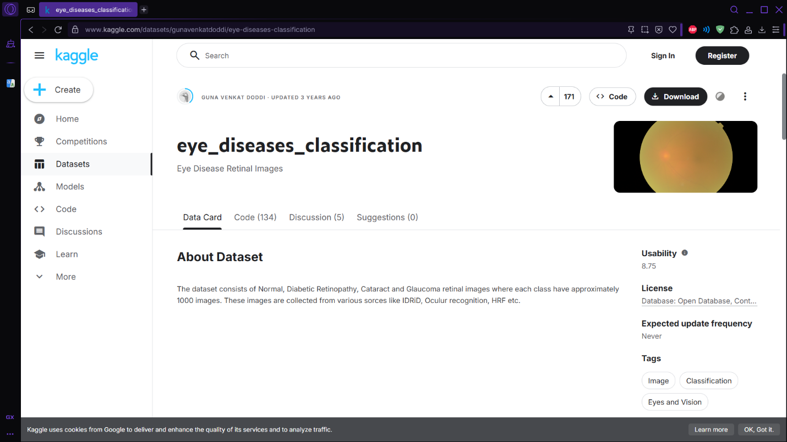Dataset of all 3 eye diseases + 1 normal retrieved from Kaggle

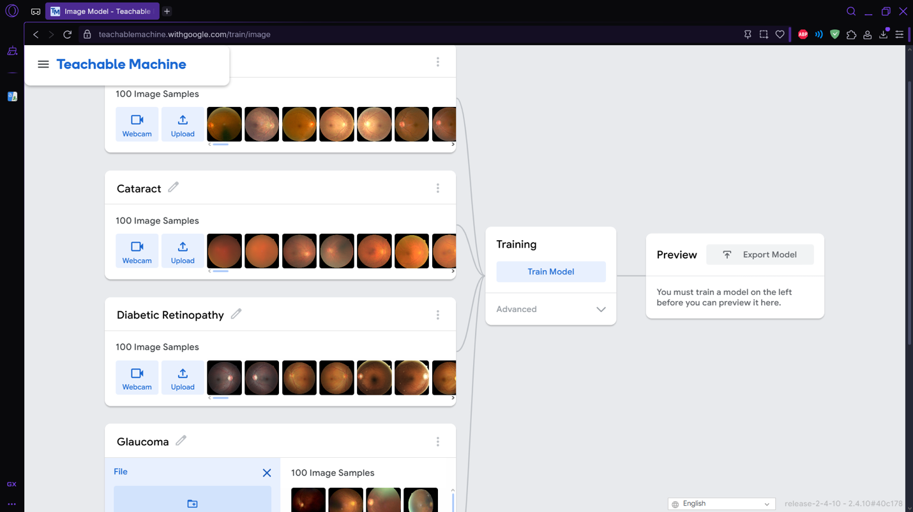Using Teachable Machine to train the model to identify the eye diseases

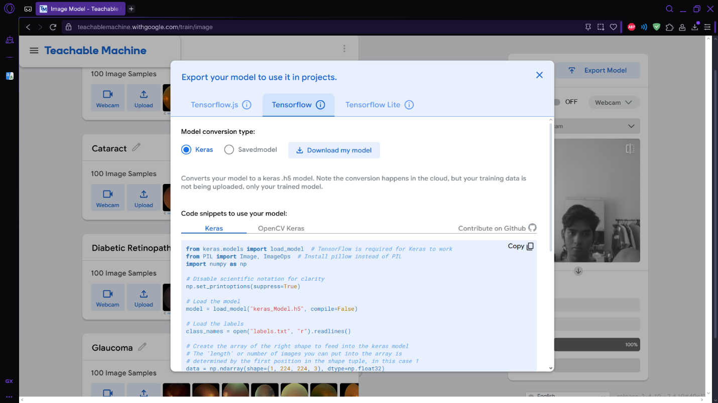Exporting our trained model into code snippets to implement it

Benefits
- Improved productivity: Automates eye disease screening, speeding up diagnosis and reducing time spent on manual checks.
- Expanded accessibility: Increases access to eye care, especially in rural or underserved areas with limited specialist availability.
- User-friendly operation: Enables healthcare workers to upload retinal images and receive fast results without needing extensive training.
- Scalable solution: Can be expanded to process more data, detect additional diseases, and integrate with telemedicine platforms.
- Cost efficiency: Lowers healthcare costs by minimizing the need for expensive equipment and reducing specialist visits.

PART D: User Manual
- Open the anaconda navigator and run terminal Test
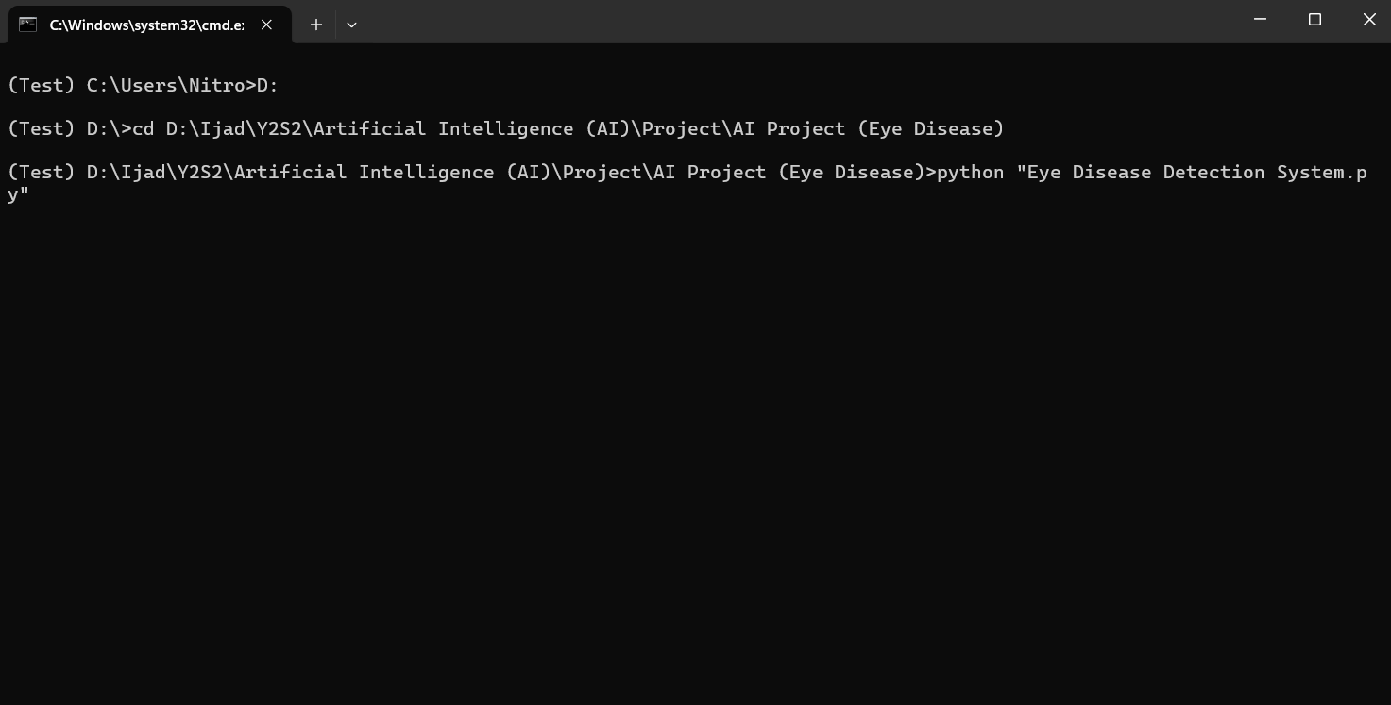Go to folder location

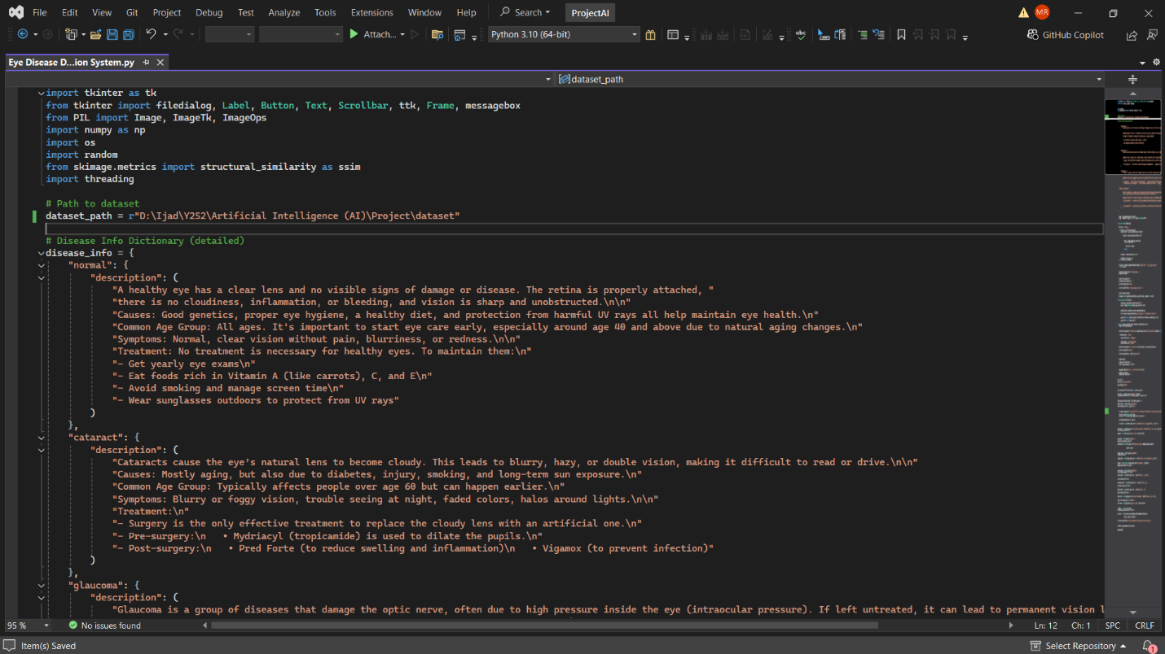Source code in the Visual Studio environment

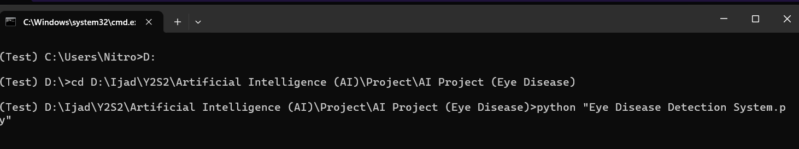Run the program

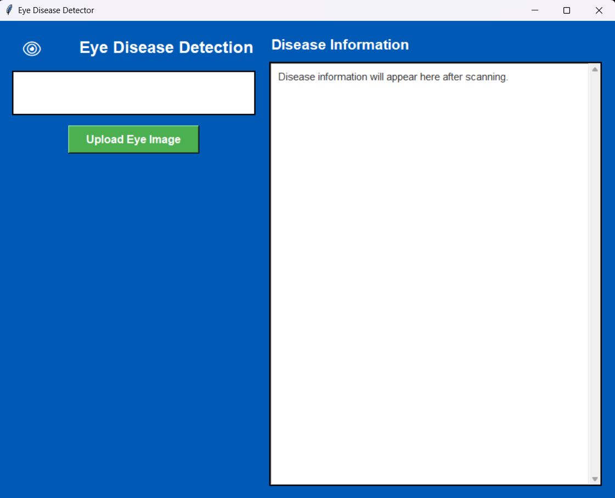
Main menu of the eye detection program

PART E: Testing Results
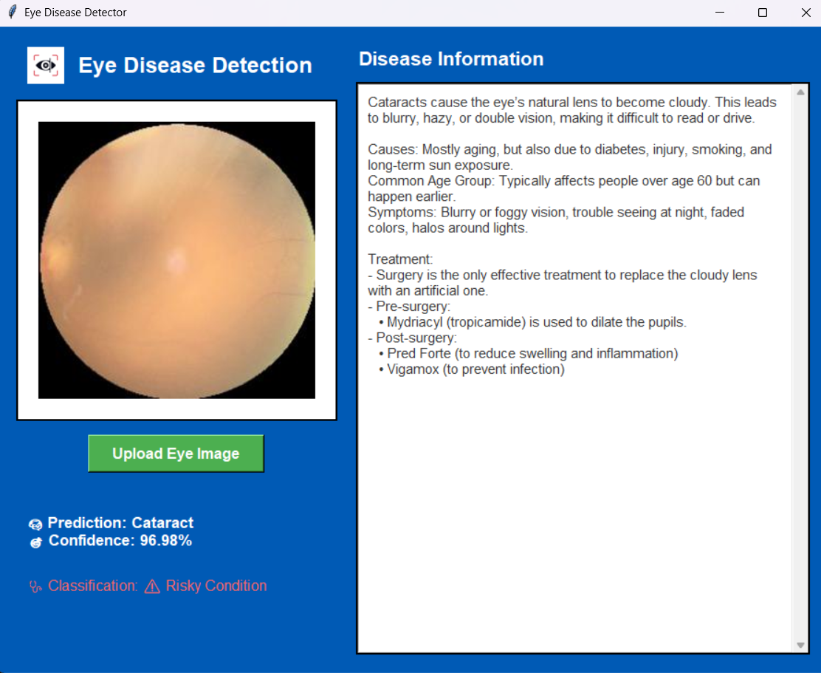

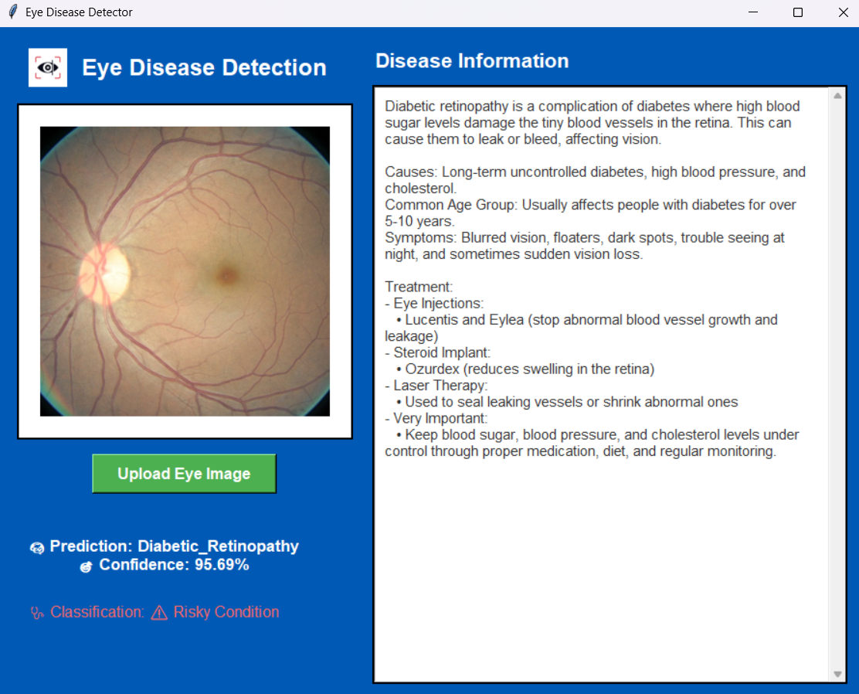

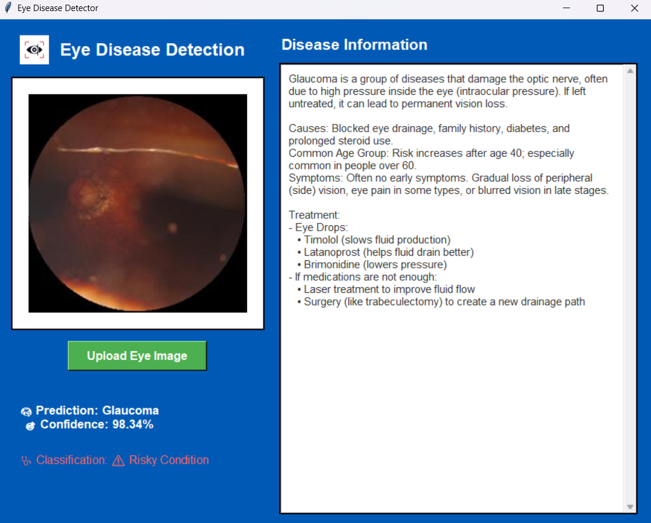

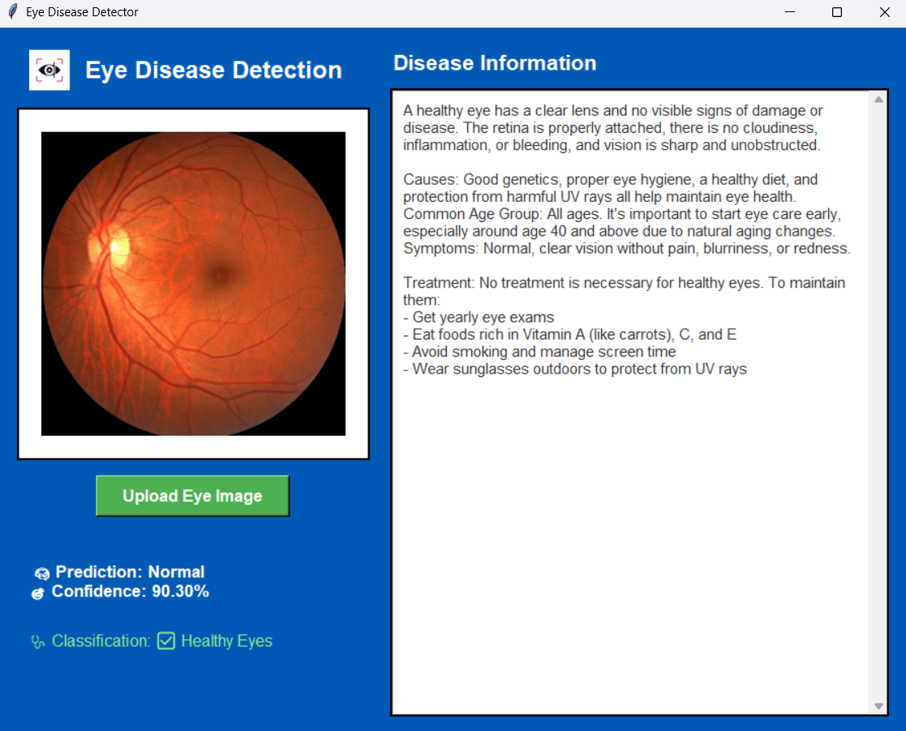

Conclusion
This AI-powered eye disease detection system offers a fast, accessible, and cost-effective solution to improve early diagnosis and treatment of eye conditions. By automating screenings and enabling remote diagnosis, the system helps reduce the burden on medical professionals, increases access to care in underserved areas, and supports better patient outcomes. Its scalability and user-friendly design make it a valuable tool for enhancing global eye health.

References
- Peng, Y., Lin, T., Wang, M., Li, Y., Zhang, W., & Zhong, X. (2025). Artificial intelligence for early detection of diabetes mellitus using OCTA images. Journal of Medical Imaging and Health Informatics, 15(2), 345–355.

- World Health Organization. (2019). World report on vision. World Health Organization. https://www.who.int/publications/i/item/9789241516570

- Zhou, Y., Chia, M. A., Wagner, S. K., Ayhan, M. S., Williamson, D. J., Struyven, R. R., Liu, T., Xu, M., Lozano, M. G., Woodward‑Court, P., Kelly, C., Jhanji, V., Keane, P. A.,
& Fu, D. J. (2023). A foundation model for generalizable disease detection from
retinal images. Nature, 622(7981), 156–163.

